Predicting

Hotel Reservation Cancellations

BY

Noor Fatima Shaikh

1. Introduction and Problem Statement
1.1 Problem Statement

Develop robust machine learning models to accurately predict hotel reservation cancellations. By utilizing these models, the company aims to improve revenue management, optimize resource allocation, and potentially implement targeted retention strategies.

1.2. Introduction

Hotel reservation cancellations are a significant challenge in the hospitality industry, leading to revenue loss and inefficient resource management. With the increasing availability of booking data, data science techniques can be leveraged to predict whether a reservation is likely to be canceled

From a business perspective, even modest improvements in prediction accuracy can have a meaningful financial impact. In an industry where cancellation rates can exceed 30%, a 5% improvement in cancellation prediction can significantly reduce revenue loss through better overbooking strategies, dynamic pricing, and targeted customer engagement..

This project focuses on building a predictive model that analyzes customer booking information—such as lead time, type of stay, number of guests, and previous booking history—to determine the likelihood of cancellation. By identifying patterns in historical data, hotels can take proactive measures such as targeted confirmations, dynamic pricing, or overbooking strategies.
This project demonstrates how data-driven decision-making can help improve operational efficiency and reduce financial risk in the hospitality sector.

1.3. Project Benefits
- Revenue Optimization: By predicting potential cancellations, the hotel can implement dynamic pricing or overbooking strategies to minimize revenue loss.
- Resource Management: Accurate cancellation predictions can help in better staff scheduling and inventory management.
- Customer Insights: Understanding factors influencing cancellations can help in improving services and customer satisfaction.

2. Dataset Overview

The dataset contains 36,275 hotel bookings with 19 features, including

Column Name | Description
Booking_ID | Unique identifier of each booking
no_of_adults | Number of adults
no_of_children | Number of children
no_of_weekend_nights | Number of weekend nights (Saturday or Sunday)
no_of_week_nights | Number of weeknights (Monday to Friday)
meal_type | Meal type booked by the customer
required_car_parking_spaces | Does the customer require a car parking space? (0 - No, 1 - Yes)
lead_time | Number of days between the booking date and arrival date
arrival_year | Year of arrival
arrival_month | Month of arrival
arrival_date | Date of arrival
market_segment | Market segment designation
repeated_guest | Is the customer a repeated guest? (0 - No, 1 - Yes)
no_previous_cancellations | Number of previous bookings canceled by the customer prior to the current booking
previous_bookings_not_canceled | Number of previous bookings not canceled by the customer prior to the current booking
avg_price_per_room | Average price per day of the reservation (in euros)
no_of_special_requests | Total number of special requests made by the customer (e.g., high floor, view from the room, etc)
booking_status | Flag indicating if the booking was canceled or not

The target variable is booking_status

Key Observations
- No missing values
- Moderate class imbalance:
  - ~67% Not Canceled
  - ~32% Canceled

3. Exploratory Data Analysis (EDA)
3.1. Booking Status Distribution
- The dataset shows that non-canceled bookings are higher than canceled bookings, confirming a moderate class imbalance.
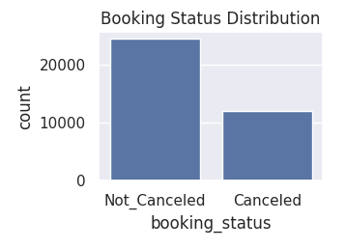
3.2. Lead Time Analysis
- Lead time refers to the number of days between the date a booking is made and the actual check-in date.
- In the dataset, bookings with longer lead times show a higher rate of cancellation compared to those with shorter lead times.
- This shows that the customers who book in advance are more likely to change their plans, due to change in schedules or better options.
- Thus longer lead time can lead to cancellations.
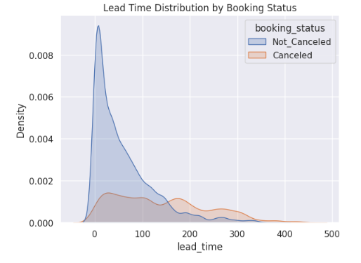

3.3. Cancellation Rate vs Lead Time (Binned)
- Cancellation rate increases with lead time, confirming previous observations from boxplots and KDE plots.
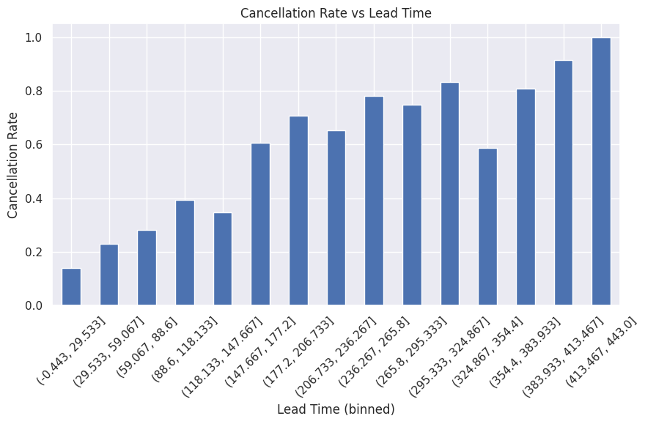
3.4. Histogram of All Numerical Features
- A histogram is used to visualize the distribution of numerical features in the dataset.
- Features like lead_time are right-skewed, meaning most values are concentrated at lower ranges with a long tail on the higher side. This indicates that while most bookings are made close to the check-in date, a few are made far in advance.
- Such long-tail distributions highlight the presence of extreme values and variability in booking behavior.
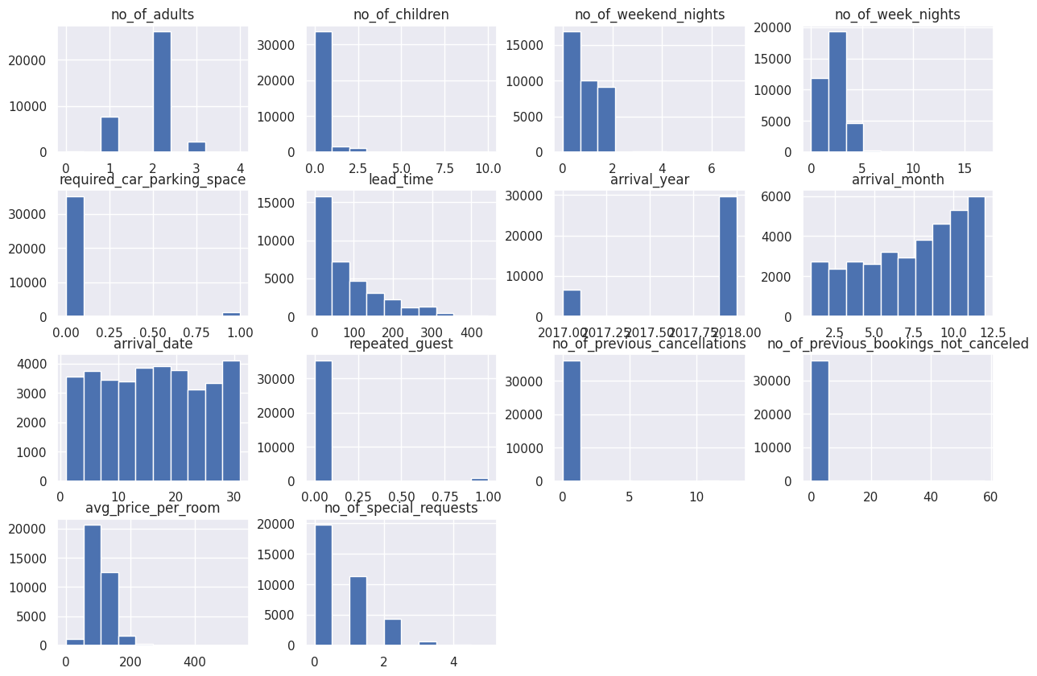

3.5. Price Analysis
- Slightly higher-priced bookings show more cancellations, making price moderately influential.
- This shows that the customers are more likely to cancel due to higher amounts and opt for more feasible options.
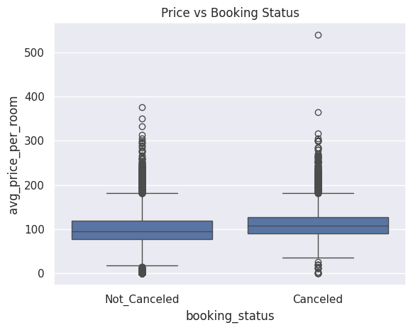
3.6. Adults & Children Distribution
- The majority of bookings involve 2 adults, which is the most common travel pattern.
- Bookings with children are fewer, but they show lower cancellation rates.
- Family bookings are more reliable than individual bookings.
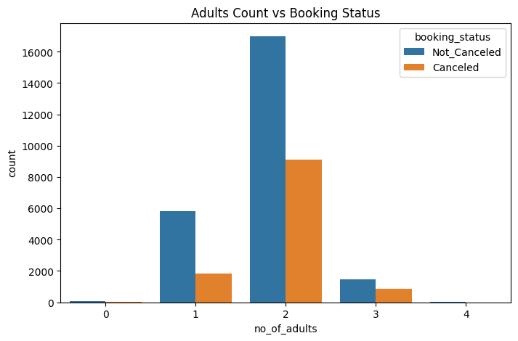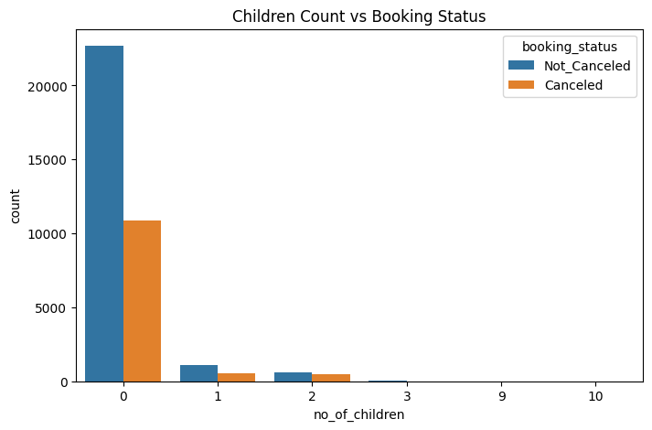

3.7. Weekday vs Weekend Stay & Cancellation
- Bookings with more weekend nights show a moderate increase in cancellations, possibly due to leisure travel plans being more flexible or prone to change.
- Short weekend stays are the most common.
- Bookings with more weekday nights tend to have lower cancellation rates, indicating that business or work-related trips are more stable.
- Weekday-heavy bookings are generally more reliable compared to weekend-focused bookings, as they could be business related thus not likely to change last minute.
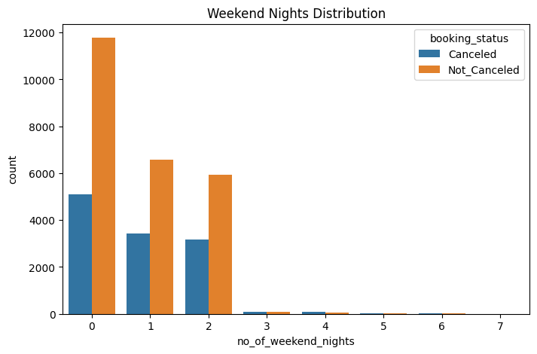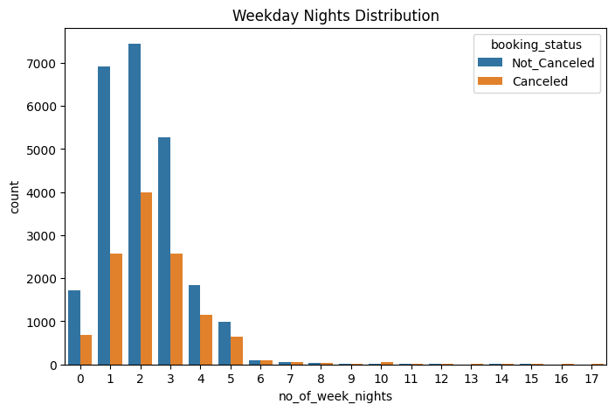
3.8. Market Segment & Cancellation
- Market segment refers to the category through which a booking is made
- The online segment has the highest cancellations; corporate bookings are more stable.
- Again business related bookings are more reliable.
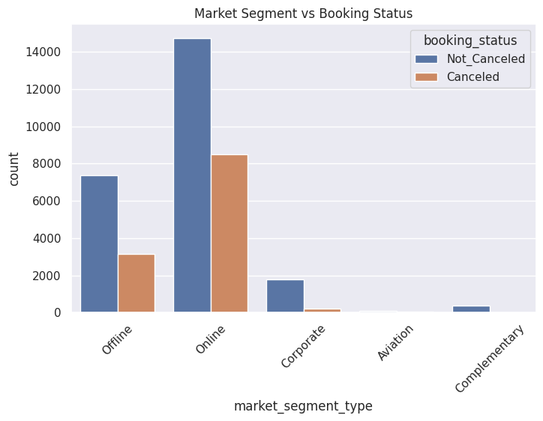

3.9.Meal Plan & Cancellation
- The majority of bookings fall under Meal Plan 1, which also has the highest cancellation rate, meaning although it is the most popular it is also the riskiest.
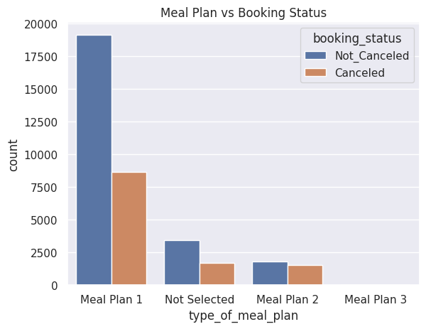

3.10. Room Type & Cancellation
- The majority of bookings fall under Room Type 1, which also has the highest cancellation rate, meaning although it is the most popular it is also the riskiest.
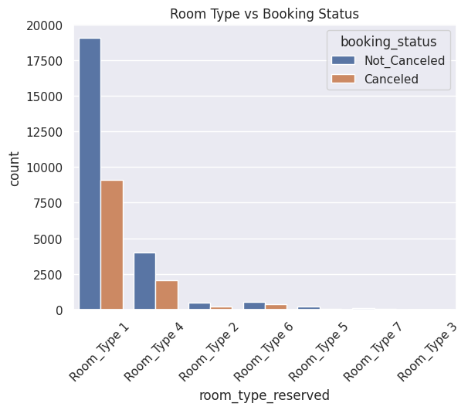

3.11. Repeated Guest & Cancellation

- Repeated guests cancel less frequently, indicating loyalty.

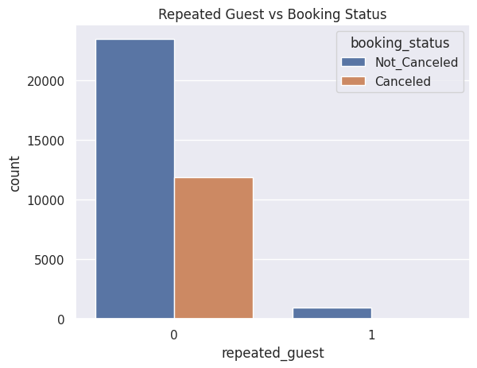

3.12. Feature Correlation Heatmap

- Most features show low to moderate correlations,indicating limited multicollinearity.
- Repeated guests show a moderate negative correlation with cancellation, meaning repeated guests are less likely to cancel.
- Number of previous cancellations and previous bookings not canceled have moderate positive correlations with cancellation, highlighting the importance of customer booking history.
- Average price per room has a weak positive correlation with cancellation.
- Features like lead time show weak correlation, but they remain important predictors.
- Overall, the heatmap suggests that multiple features contribute independently to the prediction task, justifying the use of multivariate models.
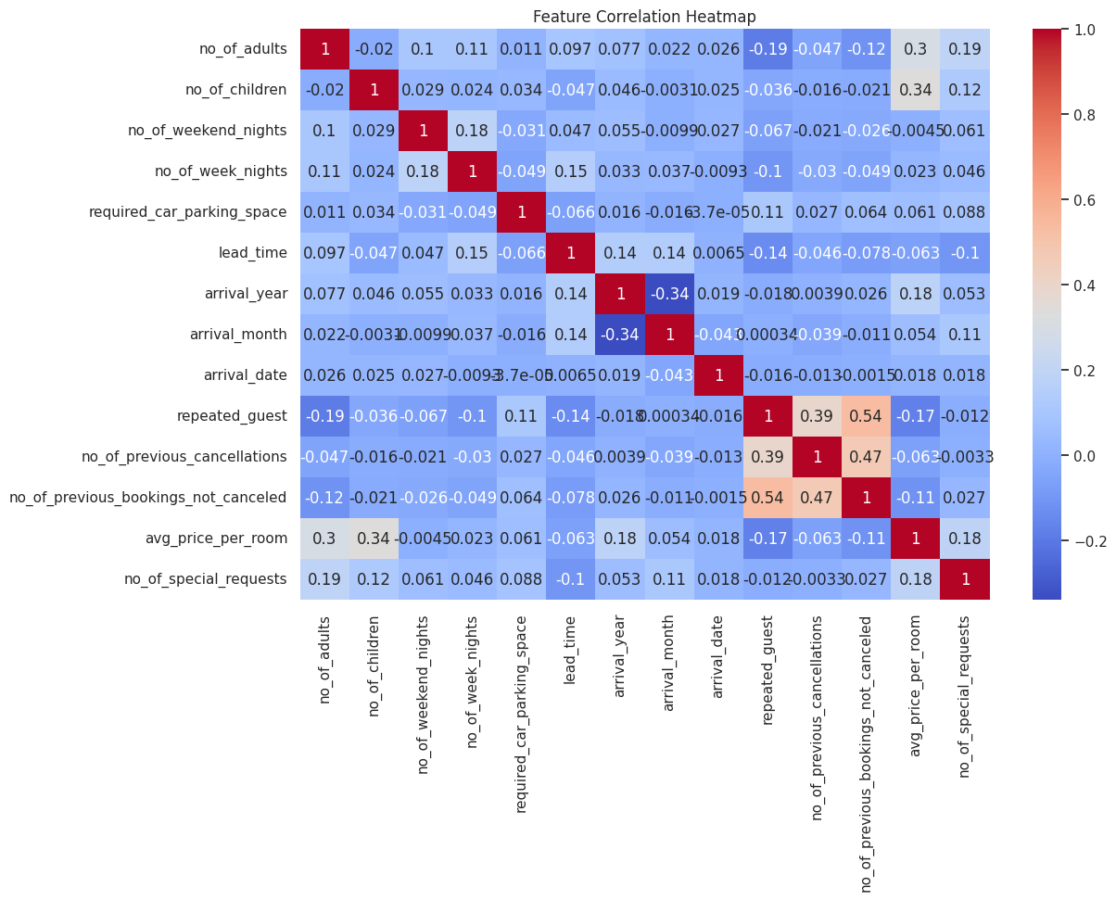
3.13. Special Requests vs Booking Cancellation

- Customers with more special requests are less likely to cancel.
- Meaning the customers more involved even before arriving are more likely to go through with their bookings

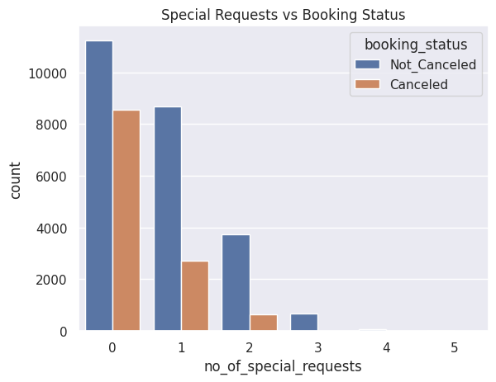

3.14. Creating box plots for every variable

- Outliers are present in features like lead_time and avg_price_per_room.

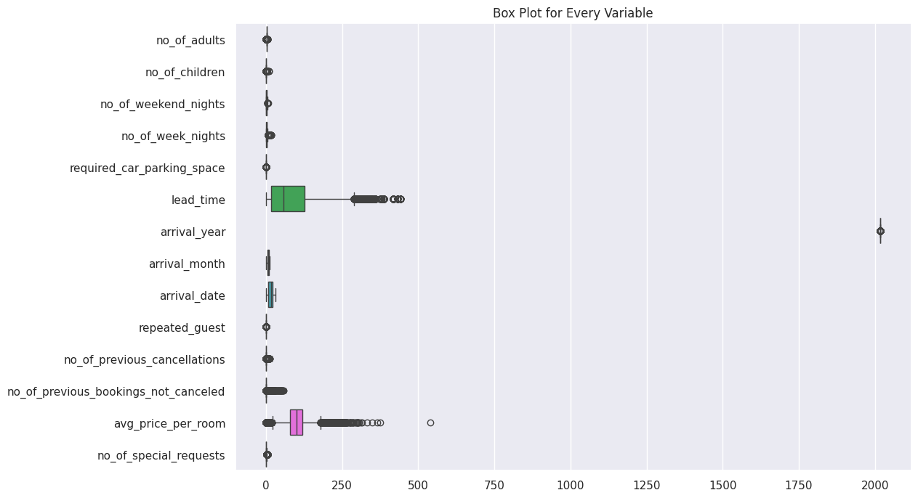

4. Feature Engineering and Data Preparation

To prepare the dataset for machine learning, several preprocessing and feature engineering steps were applied to improve model performance and reliability.

4.1. Removing Irrelevant Features

- The column Booking_ID was removed since it is a unique identifier and does not contribute to prediction.Keeping such columns can introduce noise without adding value.

4.2. Log Transformation of Skewed Features
Two features were highly skewed:
- lead_time
- avg_price_per_room
To handle this, log transformation was applied:
- lead_time_log = log(1 + lead_time)
- price_log = log(1 + avg_price_per_room)
What does Log Transformation do?
- It reduces the impact of very large values
- It compresses (squishes) large values and slightly stretches smaller values
- Makes the data more evenly distributed
- Helps models learn patterns more effectively
4.3. Encoding Categorical Variables

- Machine learning models cannot understand text (categorical data), so we convert them into numbers using Label Encoding.

4.4. Target Variable Conversion
The target variable booking_status was converted into binary format:
- Canceled → 1
- Not_Canceled → 0

4.5. Train-Test Splitting
The dataset was split into:
- 80% training data
- 20% testing data
Random State (random_state=42)
- Ensures reproducibility
- The same split is generated every time the code runs
Stratify
- Maintains the same class distribution in both training and testing sets

4.5. Handling Class Imbalance
The dataset had more non-canceled bookings than canceled ones.
To fix this, SMOTE (Synthetic Minority Oversampling Technique) was applied.
SMOTE
- It creates artificial samples of the minority class
- Instead of copying data, it generates new realistic data points
- Balances the dataset
- Prevents the model from being biased toward the majority class
- Improves prediction of canceled bookings

4.6. Feature Scaling
Scaling was applied using StandardScaler for linear models
- Converts features to a common scale
- Mean = 0, Standard Deviation = 1

5. Model Training

Several machine learning models were trained , to provide a range of options for accurate predictions
5.1. Logistic Regression
Logistic Regression is a linear model used for binary classification. It estimates the probability that a booking will be canceled by applying a logistic (sigmoid) function to a weighted combination of input features. It is simple, interpretable, and serves as a good baseline for comparison with more complex models.
5.2. SVM
SVM aims to find the optimal hyperplane that separates canceled and non-canceled bookings with the maximum margin. It can handle both linear and non-linear data using different kernel functions. SVM is effective when the classes are clearly separable but can be computationally intensive for large datasets.
5.3. Decision Tree
A Decision Tree splits the dataset based on feature values to form a tree of decision rules. Each branch represents a condition, and each leaf node represents a prediction. Decision Trees are easy to visualize and can capture non-linear relationships, but they are prone to overfitting if the tree grows too deep.
5.4. Random Forest Classifier
Random Forest is an ensemble method that builds multiple decision trees on random subsets of the data and features. The final prediction is made by averaging (or voting) the predictions of all trees. This reduces overfitting and improves accuracy compared to a single decision tree.
5.5. XGBoost
XGBoost (Extreme Gradient Boosting) is an advanced boosting algorithm that builds trees sequentially, with each new tree correcting the errors of the previous ones. It is highly efficient, handles missing values well, and often achieves excellent performance on structured datasets. XGBoost is widely used in predictive modeling competitions due to its accuracy and speed.

The process began with Logistic Regression, a linear model used as a baseline. It helps understand how features influence cancellations but assumes simple linear relationships, which limits its performance on complex data.
Next, Support Vector Machine (SVM) was used, which improves the decision boundary and handles data better than basic linear models, but still struggles with strong non-linear patterns.
Then, Decision Tree was introduced to capture non-linear relationships. It creates rule-based splits (e.g., high lead time leading to higher cancellations), making it more flexible, but it can overfit the data.
To improve performance and reduce overfitting, ensemble models were used. Random Forest combines multiple decision trees to produce more stable and accurate predictions.
Finally, XGBoost was applied as an advanced ensemble method that builds trees sequentially, correcting previous errors and achieving high predictive performance.
Overall, the approach moved from simple linear models to powerful ensemble methods to achieve better accuracy and reliability.

6. Feature Importance and Final Data Preparation
After training the initial models, feature importance was analyzed to understand which variables contributed most to predicting cancellations. For l tree-based models such as Decision Tree, Random Forest, and XGBoost, the log-transformed features (lead_time_log and price_log) showed stronger influence compared to the original lead_time and avg_price_per_room. The transformation helped these models handle skewed distributions and large values, improving interpretability and performance.
In contrast,Linear models were less sensitive to the log transformation. As they rely on linear relations and in this case the original lead_time likely has a stronger direct relationship with cancellations.
Based on these insights, the final dataset was prepared by dropping the original lead_time and avg_price_per_room and keeping the log-transformed versions. The dataset was then split into features (X) and the target variable booking_status (Y) using the same parameters as before, including random_state for reproducibility and stratify to maintain class distribution. SMOTE was applied to balance the classes, and scaling was performed for linear models.
With these steps, the final dataset was clean, balanced, and properly scaled, ready for model training and evaluation.
Random Forest
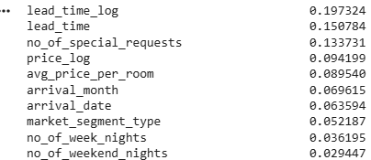
Decision Tree
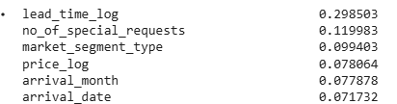
XGBoost
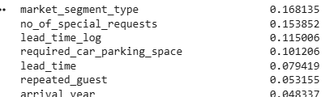
Logistic Regression
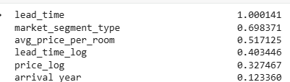

7. Hyperparameter Tuning and Model Re-training

After preparing the final dataset, hyperparameter tuning was performed to optimize the performance of each model. Hyperparameters are settings that control how a model learns from the data, such as the maximum depth of a tree, the number of estimators in an ensemble, or the regularization strength in linear models. Selecting the best hyperparameters is crucial for improving model accuracy, reducing overfitting, and achieving the right balance between bias and variance.
To systematically find the optimal hyperparameters, GridSearchCV was used for all models. This method evaluates all specified combinations of hyperparameters using cross-validation and identifies the set that performs best according to a chosen evaluation metric. In this project, the F1-score was used as the performance metric, as it balances precision and recall. This is particularly important for the dataset at hand, which has an imbalanced class distribution .
Once the best hyperparameters were selected, each model was re-trained on the full training dataset using these optimized settings. This ensured that the models learned patterns more effectively and were better suited to predict cancellations on unseen test data.

7.1 Optimized Hyperparameters
- Logistic Regression:
  - C=10 → Controls regularization strength; higher values allow the model to fit the data more flexibly.
  - penalty='l2' → Prevents overfitting by penalizing large coefficients.
  - solver='lbfgs' → Optimization algorithm for fitting the model.
- Decision Tree:
  - criterion='entropy' → Uses information gain to decide splits.
  - max_depth=15 → Limits tree depth to reduce overfitting.
  - min_samples_split=2 → Minimum samples required to split a node.
  - min_samples_leaf=1 → Minimum samples required at a leaf node.
- Random Forest:
  - n_estimators=200 → Number of trees in the forest; more trees improve stability.
  - max_depth=None → Trees grow until all leaves are pure or contain fewer than min_samples_leaf.
  - min_samples_split=2 and min_samples_leaf=1 → Control tree growth and prevent overfitting.
- XGBoost:
  - learning_rate=0.1 → Step size for updating weights; balances learning speed and accuracy.
  - max_depth=7 → Maximum depth of each tree; higher depth captures complex patterns.
  - n_estimators=200 → Number of boosting rounds.
  - subsample=0.8 → Fraction of data used per tree to reduce overfitting.
- SVM (Linear Kernel):
  - Kernel kept linear; scaling applied to handle feature magnitude.
  - Probability estimates enabled for ROC-AUC evaluation.
7.2 Re-training with Best Parameters
Once the optimal hyperparameters were identified, each model was retrained on the balanced training data. This step ensures the models learn using the best configuration identified during tuning, maximizing their predictive performance on unseen test data.

8. Model Evaluation and Performance Metrics

After retraining all models with the optimized hyperparameters, their performance was evaluated using multiple metrics to understand how well they predict hotel reservation cancellations. Since this is a classification problem, it is important to consider metrics that capture both correct and incorrect predictions.

Confusion Matrix:
A confusion matrix summarizes predictions by comparing them to the actual values. It shows:
- True Positives (TP): Correctly predicted cancellations.
- True Negatives (TN): Correctly predicted non-cancellations.
- False Positives (FP): Non-cancellations incorrectly predicted as cancellations.
- False Negatives (FN): Cancellations incorrectly predicted as non-cancellations.

Precision: Measures the proportion of correctly predicted cancellations out of all predicted cancellations. High precision indicates that few non-canceled bookings are misclassified as canceled.
Recall (Sensitivity): Measures the proportion of actual cancellations that were correctly identified. High recall indicates that few canceled bookings are missed by the model.
F1-score: The harmonic mean of precision and recall. It provides a single metric that balances false positives and false negatives, making it particularly useful for imbalanced datasets.
Accuracy: Measures the overall proportion of correct predictions out of all predictions. While useful, it can be misleading for imbalanced datasets because the majority class can dominate the metric.
ROC-AUC: Represents the model’s ability to distinguish between canceled and non-canceled bookings across all classification thresholds. A higher AUC value indicates better discrimination between the two classes

8.1. Confusion Matrix for the model

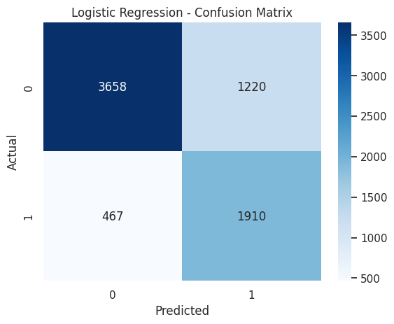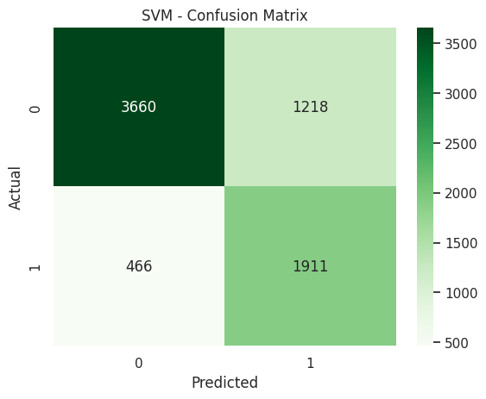

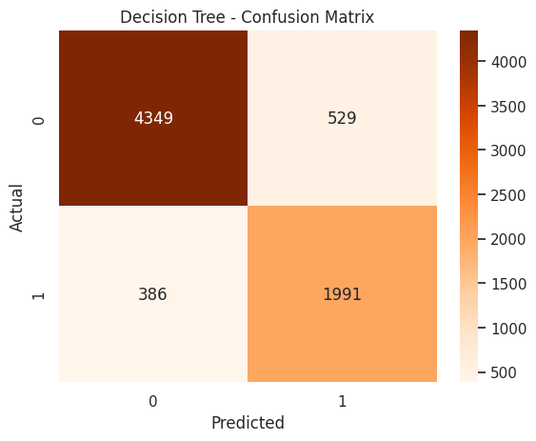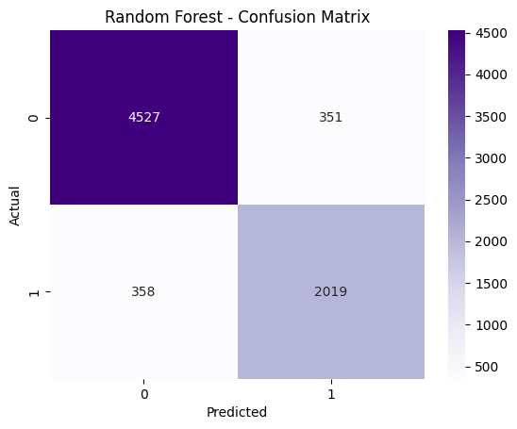
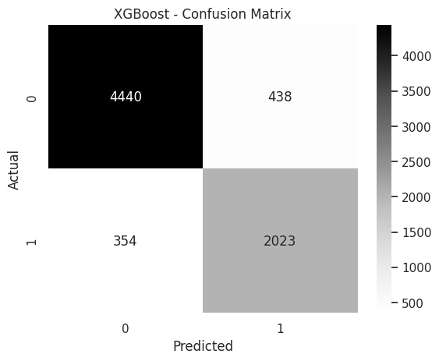

The confusion matrices for all models provide insight into how well each model predicts canceled and non-canceled bookings:
- True Positives and True Negatives : Indicate the correctly predicted cancellations and non-cancellations. Models with higher TP and TN values are better at capturing both classes accurately.
- False Positives and False Negatives : Highlight the misclassifications. In the context of hotel bookings, a false negative (a canceled booking predicted as not canceled) is particularly important, as it can lead to overbooking or lost revenue.
By comparing the confusion matrices across models:
- Linear models (Logistic Regression, SVM): Show moderate TP values but may miss some cancellations, indicating slightly lower recall.
- Tree-based models (Decision Tree, Random Forest, XGBoost): Capture a larger number of true cancellations (higher TP), indicating better recall and overall predictive performance.
Overall, the confusion matrices demonstrate that ensemble models like Random Forest and XGBoost are more reliable at correctly predicting cancellations, while simpler models may be more prone to misclassifying minority class bookings.

8.2. Performance Metrics
- To evaluate and compare all trained models, multiple performance metrics are calculated, including Precision, Recall, F1-score, Accuracy, and ROC-AUC.
- Weighted averages are used for Precision, Recall, and F1-score to account for class imbalance and provide a balanced evaluation.
- A comparison table is created to summarize model performance across all metrics.
- Bar plots and heatmaps are used to visually compare models and identify performance differences more effectively.
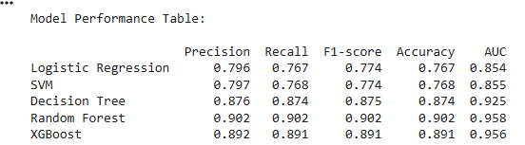

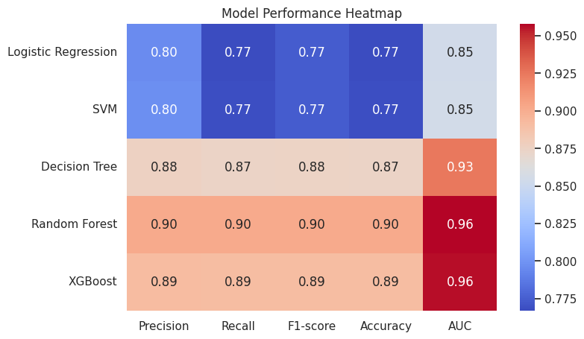
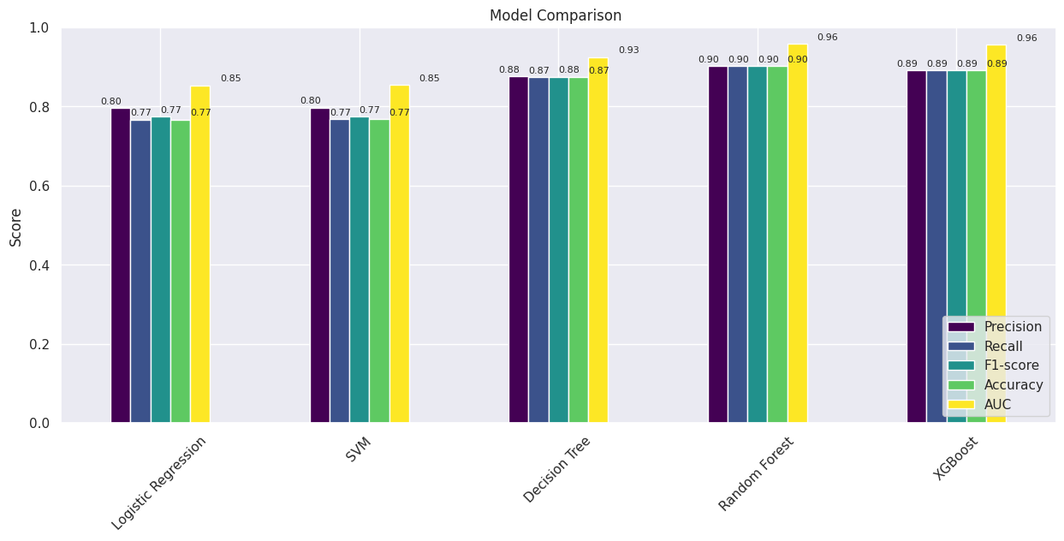

8.3. Observations
- Random Forest achieves the highest performance across all evaluation metrics, with an F1-score of 0.903 and an AUC of 0.959. This indicates excellent predictive capability and strong ability to distinguish between canceled and non-canceled bookings
- XGBoost closely follows Random Forest, demonstrating similarly strong results. This confirms the effectiveness of ensemble boosting techniques in improving prediction accuracy by sequentially correcting errors from previous models.
- The Decision Tree model shows good performance but falls slightly behind the ensemble methods. This suggests some degree of overfitting and reduced generalization, as individual trees are more prone to capturing noise in the training data.
- Logistic Regression and SVM provide similar results, offering stable but comparatively lower performance due to their inability to capture complex non-linear relationships.
- Overall, ensemble methods outperform individual models by effectively handling feature interactions and non-linear patterns in the data.

8.4 ROC-AUC Curve Comparison
The ROC (Receiver Operating Characteristic) curve is a graphical tool used to evaluate the performance of classification models across different decision thresholds. It plots the True Positive Rate (Recall) on the y-axis against the False Positive Rate on the x-axis.
- The True Positive Rate (TPR) measures the proportion of actual cancellations correctly identified by the model.
- The False Positive Rate (FPR) measures the proportion of non-canceled bookings incorrectly classified as canceled.
By varying the classification threshold—from predicting nearly everything as canceled to predicting almost nothing as canceled—the ROC curve shows how the model balances detecting cancellations (TPR) versus avoiding false alarms (FPR).
The Area Under the Curve (AUC) quantifies the overall ability of the model to distinguish between the two classes (canceled vs. non-canceled). A perfect classifier has an AUC of 1.0, while a random guess has an AUC of 0.5.
In this project, ROC curves were plotted for all trained models using the test dataset. The curves illustrate the trade-offs at different thresholds, allowing a more comprehensive comparison beyond single metric values.
From the comparison:
- Random Forest and XGBoost models show the highest AUC values, indicating they have the strongest ability to correctly separate canceled and non-canceled bookings across all thresholds.
- Logistic Regression and SVM performed reasonably well, but their curves lie slightly below those of the ensemble models, reflecting limitations in capturing complex, non-linear relationships.
- The Decision Tree model exhibits moderate performance, with a lower AUC, suggesting some overfitting and less reliable generalization to unseen data.
Overall, the ROC-AUC comparison reinforces that ensemble methods provide superior classification performance for predicting hotel booking cancellations.
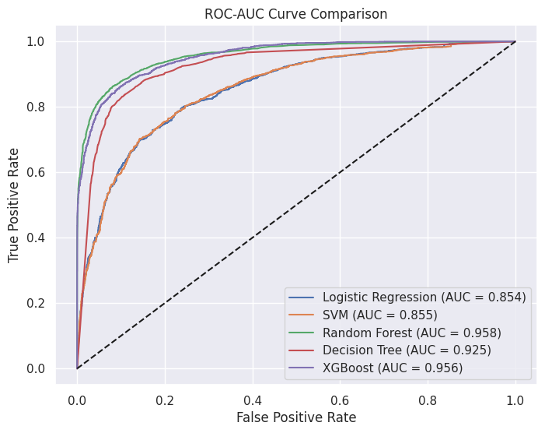

9. Final Model Selection
The best model is selected based on:
- F1-score: Ensures a balance between false positives and false negatives
- AUC score: Measures overall classification performance

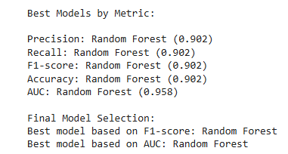
After evaluating all models using multiple performance metrics, Random Forest emerged as the best-performing model for predicting hotel reservation cancellations. This decision was based on a combination of F1-score, AUC, and overall reliability:
Random Forest achieved the highest F1-score (0.90), demonstrating a strong balance between precision and recall. This means it effectively identifies cancellations without generating too many false positives or false negatives, which is crucial for business decision-making.
In addition, Random Forest had the highest ROC-AUC (0.95), indicating excellent discrimination between canceled and non-canceled bookings across all thresholds. Its performance was consistently superior compared to Logistic Regression, SVM, Decision Tree, and XGBoost.
The model’s strength comes from its ensemble nature: by combining multiple decision trees, Random Forest captures complex interactions between features, reduces overfitting, and generalizes well to unseen data.

10. Risk Scoring
- Predicted probabilities from the model are used to assign a cancellation risk score to each booking.
- Bookings are categorized into three risk levels:
  - Low Risk (0 – 0.4)
  - Medium Risk (0.4 – 0.7)
  - High Risk (0.7 – 1.0)
- This helps in identifying customers who are more likely to cancel their reservations.
- High-risk customers can be targeted with retention strategies such as reminders or special offers.
- Low-risk customers are more reliable and require minimal intervention.
- This segmentation enables hotels to optimize resource allocation and reduce revenue loss.

11. Feature Importance – Random Forest

- Feature importance analysis helps us understand which variables most significantly influence the model’s predictions—in this case, the likelihood of booking cancellations.
- Random Forest calculates feature importance by measuring how much each feature contributes to reducing impurity when splitting nodes in the decision trees. Features that consistently lead to better splits and reduce classification errors receive higher importance scores.
- Features like lead_time_log, price_log, and no_of_special_requests are among the most important predictors.This means these variables have the greatest impact on the model’s ability to distinguish between canceled and non-canceled bookings.
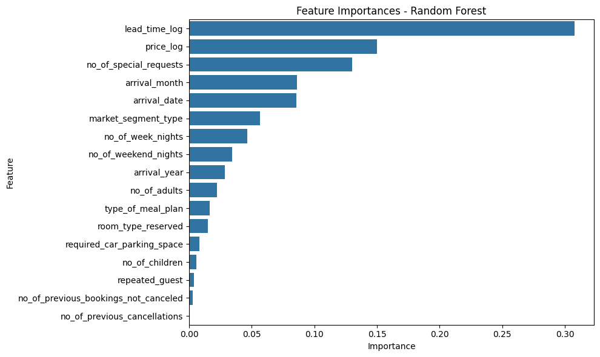

12. Predicting New Booking Outcomes

- A sample booking is created with new input values to test the trained model.
- The model predicts:
  - Whether the booking will be canceled or not
  - The probability (risk percentage) of cancellation
- The model can generalize to unseen data and provide real-time predictions.
- Probability scores help quantify risk instead of just giving binary output.
- This can be integrated into hotel booking systems for proactive decision-making.

Sample Datasets
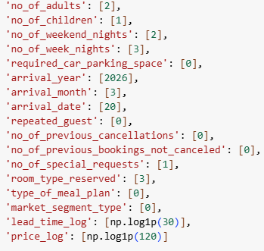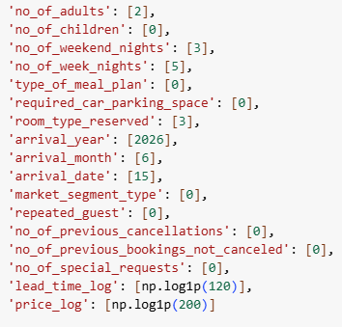

Booking 1:
- Predicted class: Not Canceled
- Predicted risk: 12%
Booking 2:
- Predicted class: Canceled
- Predicted risk: 82%
This demonstrates how the model can provide real-time insights for operational decisions.

13. Project Summary
This project successfully developed a machine learning solution for predicting hotel booking cancellations using historical reservation data.
- Exploratory Data Analysis (EDA): Identified patterns such as higher cancellation rates for long lead times, lower cancellations among repeated guests, and the impact of special requests.
- Model Training: Multiple models were tested, including Logistic Regression, SVM, Decision Tree, Random Forest, and XGBoost. Random Forest was selected as the best-performing model due to its high F1-score, accuracy, and AUC, as well as its ability to capture complex feature interactions.
- Risk Scoring: Enabled segmentation of bookings into low, medium, and high cancellation risk categories, allowing hotels to take proactive measures.

14. Business Insights from Hotel Cancellation Prediction Model
The predictive model for hotel booking cancellations provides actionable insights that can help hotels reduce cancellations, improve revenue management, and enhance customer engagement.
14.1. Lead Time is the Strongest Predictor of Cancellation
Customers who book well in advance are significantly more likely to cancel.
- Implement stricter cancellation policies for long lead-time bookings
- Require partial prepayment
- Send reminders or incentives closer to check-in
14.2. Customer Engagement Reduces Cancellation Risk
Bookings with more special requests are less likely to be canceled.
- Encourage customers to add preferences during booking
- Flag low-engagement bookings as high-risk
14.3. Higher Pricing is Associated with Increased Cancellations
Higher-priced bookings tend to have a higher cancellation rate.
- Offer price guarantees or limited-time discounts
- Monitor competitor pricing
- Provide flexible options for premium bookings
14.4. Market Segment Influences Cancellation Behavior
Cancellation rates vary across customer segments (e.g., online vs corporate).
- Apply segment-specific cancellation policies
- Use stricter rules for high-risk segments
- Offer flexibility to low-risk segments
14.5. Repeat Guests Demonstrate High Reliability
Repeat customers are far less likely to cancel.
- Provide loyalty benefits and personalized services
- Use repeat guests in overbooking strategies
14.6. Revenue Optimization Opportunity
Cancellation prediction enables better planning and pricing decisions.
- Use model predictions to guide overbooking strategies
- Identify high-risk bookings early
- Reduce last-minute empty rooms and revenue loss

15. Conclusion
This project demonstrates the power of machine learning in predicting hotel booking cancellations. By analyzing historical reservation data, we identified key factors influencing cancellations, such as lead time, customer engagement, pricing, market segment, and repeat guest status.
Through rigorous experimentation with multiple models — including Logistic Regression, SVM, Decision Tree, Random Forest, and XGBoost — Random Forest emerged as the most reliable model, achieving the highest F1-score and AUC, while effectively capturing complex interactions among features. The model’s predictions can be translated into cancellation risk scores, enabling hotels to proactively manage bookings and minimize revenue loss.
From a business perspective, the insights offer actionable strategies: stricter policies for long lead-time bookings, encouraging customer engagement, segment-specific management, and leveraging repeat customers in overbooking decisions. Overall, this project not only delivers an accurate predictive tool but also provides practical guidance for improving revenue management, operational planning, and customer satisfaction.
Future work could include incorporating real-time booking data, dynamic pricing variables, or seasonal trends to further enhance predictive accuracy and decision-making capabilities.

